DotNetProxy Installation Procedure

File Manifest
The following is a list of the files that are included with this distribution.

- DotNetProxy.dll
- DotNetProxy.tlb
- Documentation.chm
- Gacutil.exe
- RegisterProxy.bat
- UnregisterProxy.bat

Before starting, make sure that you have all of the above files.

Server Setup
In order to setup the DotNetProxy on the server, create a shared directory which the clients will access for the installation procedure and general day to day use.

For example:
\\MyServer\DotNetProxyHost\

Place all the files listed in the manifest in this folder.

Client Setup
To setup the client machine navigate to the shared directory on the server (in the DTV automation project the link for the directory to be mapped is: \\172.20.201.164\ElementaryActionsProxy\) and run the file RegisterProxy.bat by double-clicking on it. When asked about altering security policy, type “yes” (this could take a few seconds up to 2-3 minutes).

The resulting window should look something like this:

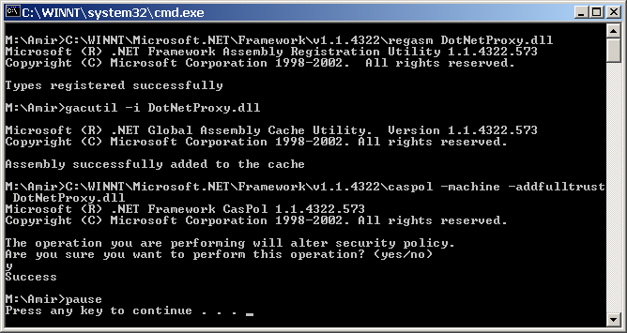

Press any key to close this window.

Click on Start|Settings|Control Panel. When it opens double-click on Administrative Tools and then on Microsoft .NET Framework 1.1 Configuration.

In the tree on the left hand side navigate, as shown in the picture, to:
My Computer\Runtime Security Policy\Machine\All_Code\LocalIntranet_Zone

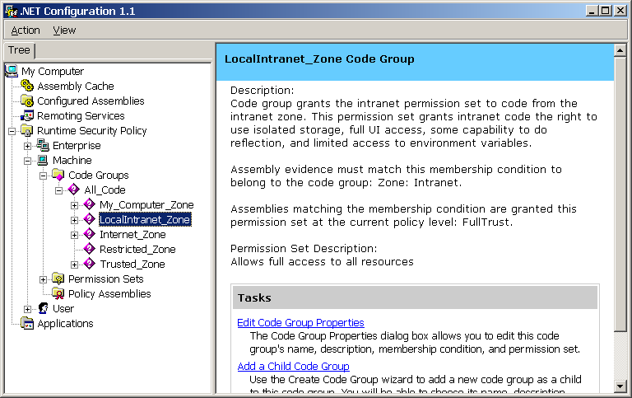

Click on Edit Code Group Properties in the right hand side, this should bring up a window that looks like this:
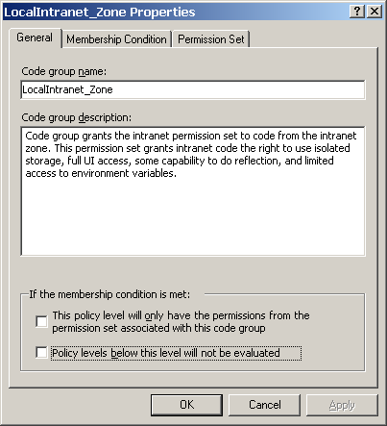

Click on Permission Set to open that tab. You should now see a screen like this:
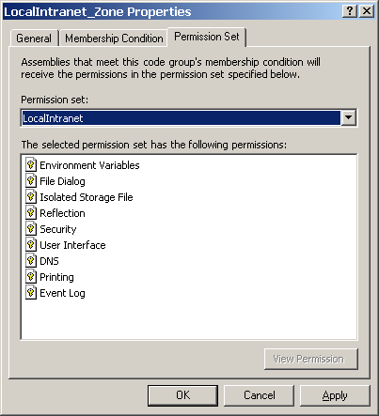

Change the Permission Set dropdown from LocalIntranet to FullTrust, then click Apply and OK..
Back on the main setup page, choose Run Time Security Policy:

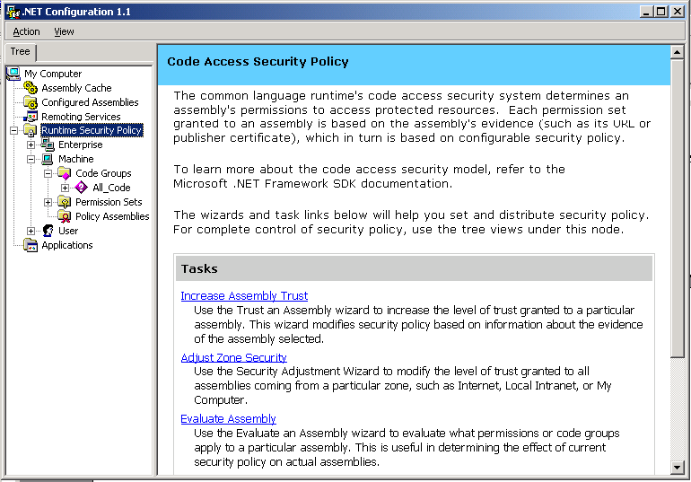

Click on Increase Assembly Trust on the right hand side of the screen ,this should brig up a screen that looks like this:
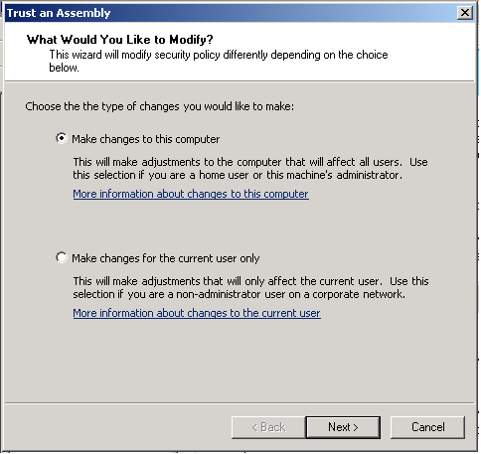

Click on Next when the default choice (Make Changes to this computer) is chosen.

You should get a screen that looks like this:

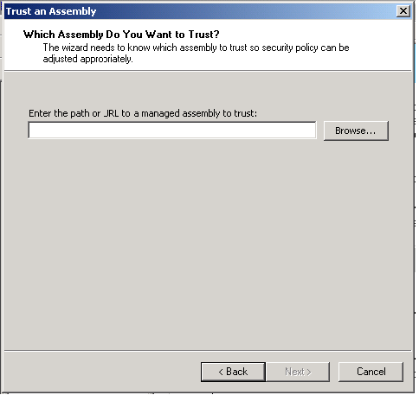

Click on Browse, navigate to the mapped drive that maps the shared directory on the server (from the beginning of the installation procedure), select the ElementaryActions.dll file and click Open. Now the path and name of the file should appear in the text box.

Click on Next. On the screen you get change the trust level to Full Trust (the highest). Your screen should now look like this:

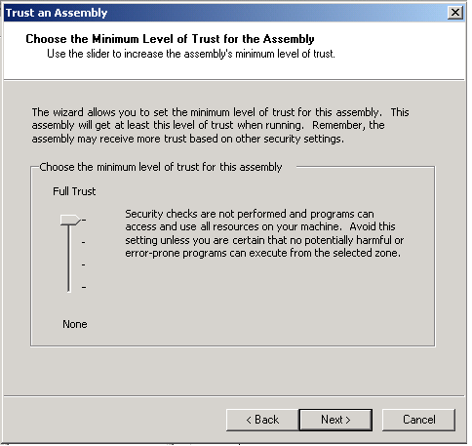

Click Next.

Your screen should look like this:

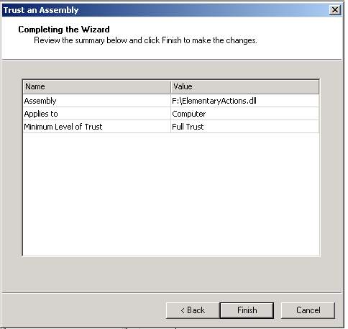

(the drive letter F: can be different on your machine, according to what you mapped).

Click Finish. Close all windows that were opened during the installation.

The setup procedure should now be completed.

